Solutions Page (All solutions on one page)
Hero:
Badge: Solutions
Heading: Solutions Built Around Real Construction Workflows.
Paragraph: Explore the platforms, AI systems, and workflow solutions we've engineered to solve practical challenges across façade and construction operations.
Note:
In the below image:
- Move the hero section to the centre of the page.
- Don’t add image on hero section.
- Don’t show stats on hero section. Skip the stats.
- On each row there should be only 3 solution cards.
- Total make 9 cards for solutions
- For each solution card, add badge, mock-up, solution name, solution short description, short cards for category, and button for Explore solution.
- Skip the last CTA section. Second last CTA section should be last section of solutions page.
- Keep CTA section in centre of page (don’t add image on CTA section).

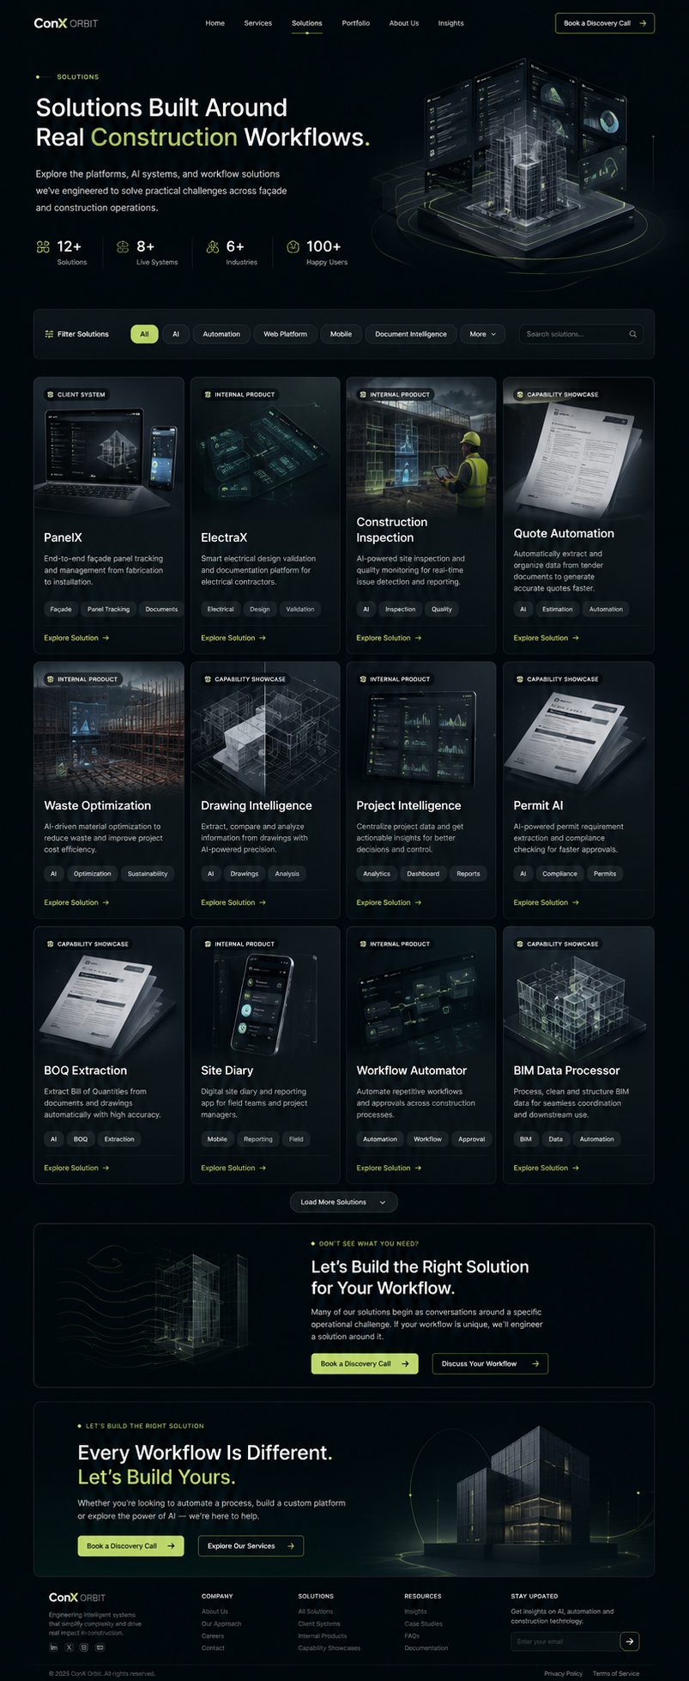

Individual Solution Page
1-Hero:
Structure should be like this. Left side content and right-side image of solution.
Write solution name on top as Badge.
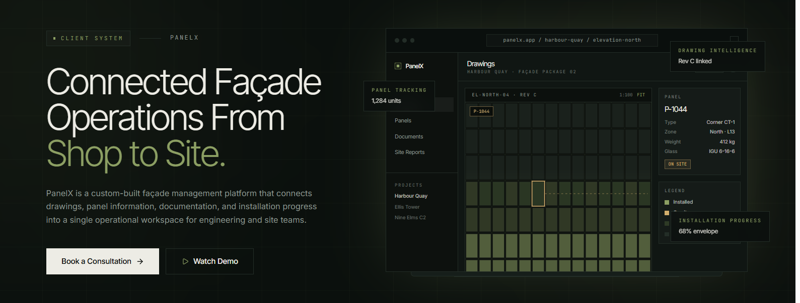
Below hero section Add a stats section like this:
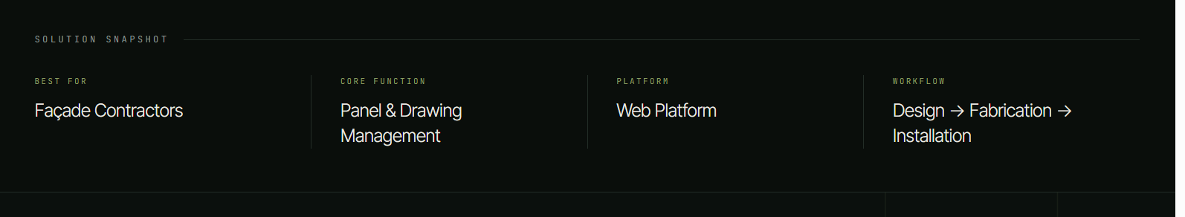
Just write 3 things:
Best For, Core Function, Platform. Don’t write Workflow.
2-The Challenge
Badge: THE CHALLENGE
Heading: Disconnected Workflows Slow Down Every Project.
Paragraph:
Façade teams often work across drawings, spreadsheets, documents, site photos, and disconnected project tools. Panel information becomes difficult to track, updates are scattered, and site visibility suffers.
Problem Cards:
- Manual Tracking
- Disconnected Drawings
- Scattered Documents
- Limited Site Visibility
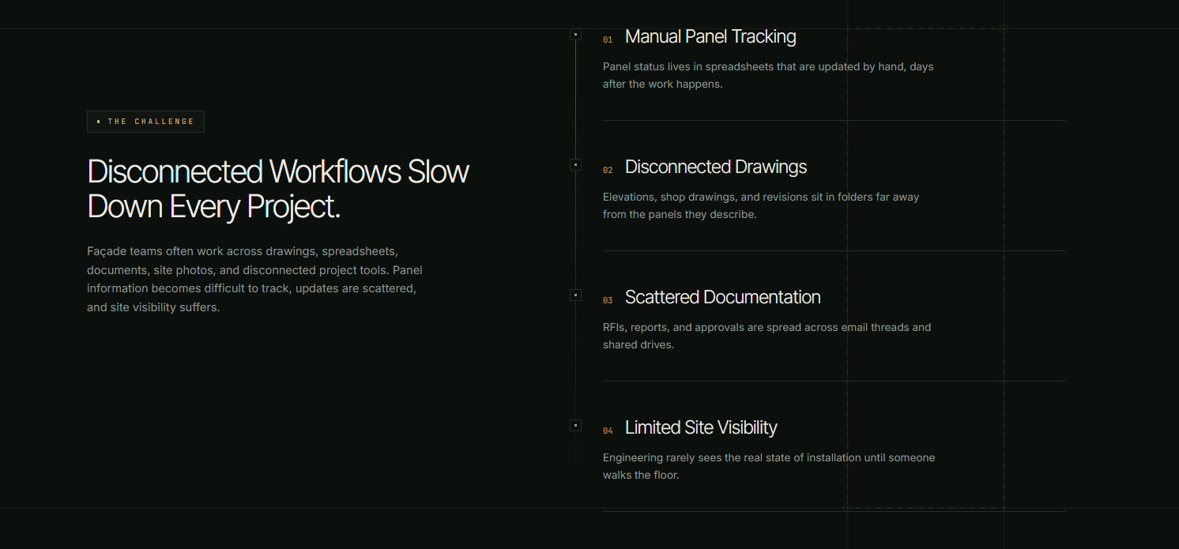

3-Solution Capabilities
Badge: CAPABILITIES
Heading: Everything Needed to Manage Façade Operations.
Large Capabilities Card
1-Drawing Viewer
Open and navigate drawings directly inside the platform.
2-Panel Tracking
Track every panel through fabrication and installation.
3-Document Management
Keep RFIs, reports and technical documents connected - at one place.
4-Site Documentation
Capture progress with linked photos and reports.
5-Search & Filtering
Locate any panel or drawing instantly.
6-Installation Monitoring
View live installation progress across projects.
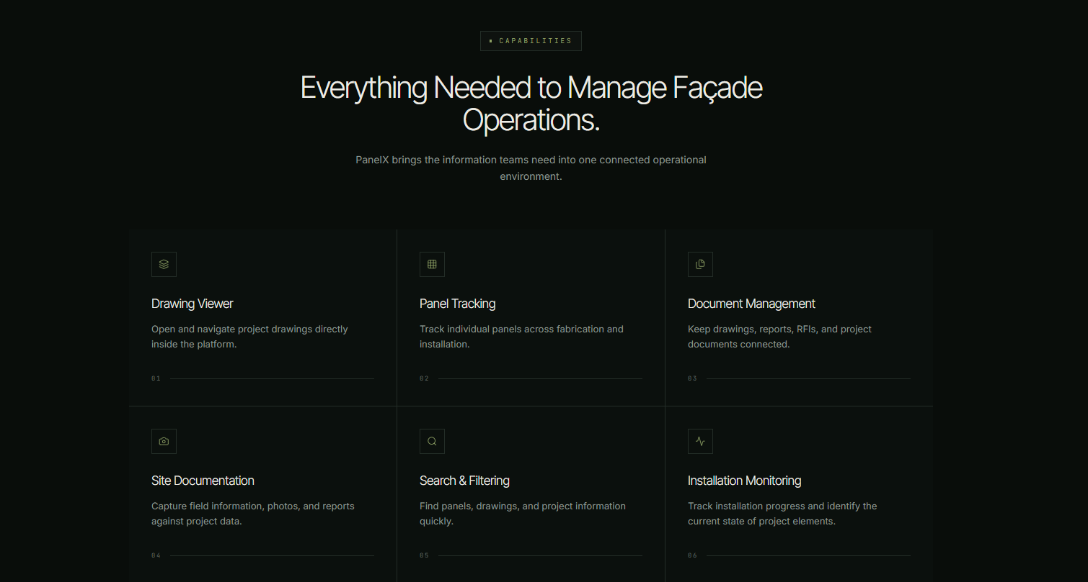
4-How it Works
Make progress bar for this section. Add icons
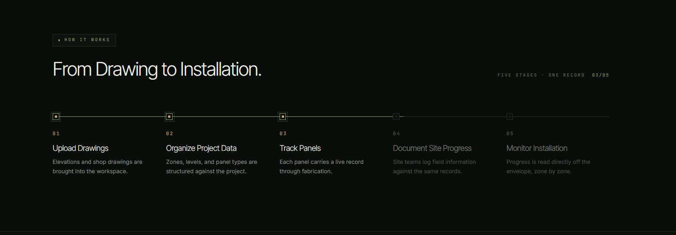
5-Built for
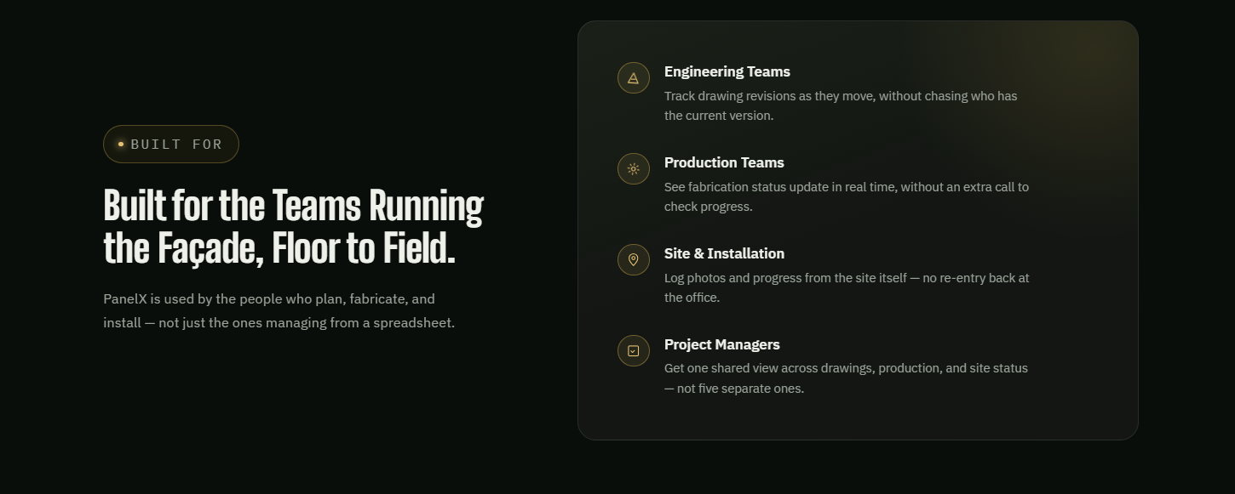
6-Demo
A video section simply with heading
Heading: See it in Action
When user clicks on Watch Demo button on hero section it should scroll the user down to this section.
7-More Solutions Section
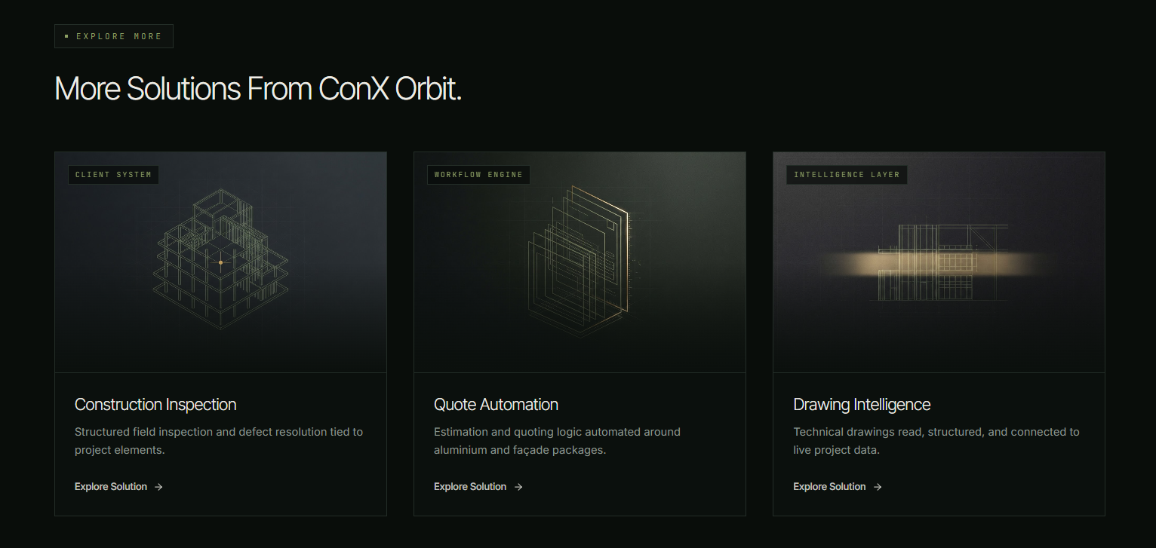
8- FAQ
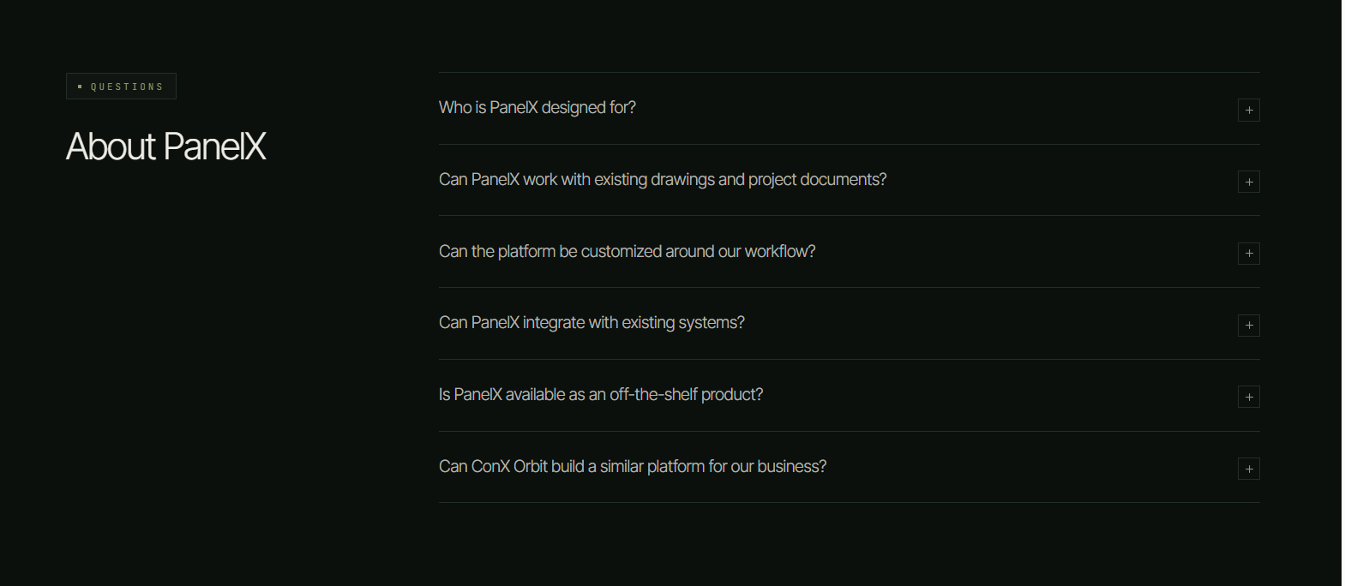
9- CTA
Badge: EXPLORE WHAT'S POSSIBLE
Heading: Could a System Like This Work for Your Workflow?
Paragraph: Tell us how your team works today. We'll explore the challenges you're facing and discuss what a tailored solution could look like for your business.
Button: Book a Consultation →, Explore Solutions →

